 Shri Ramdeobaba College of Engineering & Management, Nagpur 13

Department of Electronics Engineering

Instrumentation and control lab (ENP354)

Semester: V Session: 2023-24 Section: A Batch: A2

# ******************************************************************************************

Name of Student: Harsh Devendra Mishra Roll Number: 22

Date of performance of Experiment: 23 / 11 / 2023 Date of Submission of Experiment file: 30 / 11 / 2023

******************************************************************************************

# EXPERIMENT NO. 5

Aim of Experiment: - Measurement of Electrical conductivity of solution.

Objective of Experiment: -

* Identify whether a solution is conductive.
* Construct a functional conductivity probe.
* Integrate a conductivity probe into a simple circuit.
* Utilize an Arduino with LCD display-to-display probe values.
* Determine the conductivity of an unknown solution.

Tool used: - Arduino, Bread Board, Sensor, power supply, Connecting wires, Laptop/Computer system

********************************************************************************************************

The conduction of current through a water solution is primarily dependent on the concentration of dissolved ionic substances such as salt. Since most fresh water derives from relatively clean rainfall, variations in EC provide a way to track the chemical and hydrological processes the water has been subjected to over time. High amounts of dissolved substances (usually referred to as salinity) can prevent the use of waters for irrigation and drinking, so conductivity ranks as one of the most important inorganic water quality parameters.

Conductivity, Salinity & Total Dissolved Solids

-discusses the older TDS measurements in parts per million ( ppm ) which makes assumptions about the charge carriers that don’t reflect real world environments. The conversion factor from EC (which is the thing you actually measure) to TDS changes for different dissolved solids, so instruments from different manufacturers often give you different TDS readings for the same solution, because the companies made different assumptions about what’s in your water. Because of this confusion, straight EC measurements in siemens have been adopted as the standard by the international scientific community. One siemens is equal to the reciprocal of one ohm (S = 1/Ω) and is also sometimes also referred to as the mho (℧) in older literature.

The ability of water to conduct an electric current is known as conductivity or specific conductance and depends on the concentration of ions in solution. Conductivity is measured in millisiemens per metre (1 mS m-1 = 10 µS cm-1 = 10 µmhos cm-1). The measurement should be made in situ, or in the field immediately after a water sample has been obtained, because conductivity changes with storage time. Conductivity is also temperature dependent; thus, if the meter used for measuring conductivity is not equipped with automatic temperature correction, the temperature of the sample should be measured and recorded.

Scientific equipment like conductivity meter, consists of a conductivity cell containing two rigidly attached electrodes, which are connected by cables to the body of the meter. The meter contains a source of electric current (a battery in the case of portable models), a Wheatstone bridge (a device for measuring electrical resistance) and a small indicator (usually a galvanometer). Some meters are arranged to provide a reading in units of conductance (mhos), while others are graduated in units of resistance (ohms). The conductivity cell forms one arm of the Wheatstone bridge. The design of the electrodes, i.e. shape, size and relative position, determines the value of the cell constant, Kc, which is usually in the range 0.1 to 2.0. A cell with a constant of 2.0 is suitable for measuring conductivities from 20 to 1,000 mS m-1.

The cell constant Kc can be determined by using the apparatus to measure the conductivity of a standard solution (0.0100 mol l-1) of potassium chloride and dividing the true conductivity of the solution (127.8 mS m-1 at 20 °C) by the measured conductivity, Kc=Ct/Cm. Care must be taken to ensure that measured and true conductivities are expressed in the same units. The temperature of the solution is critical because electrolytic conductivity increases with temperature at a rate of approximately 1.9 per cent per °C. Some meters provide a reading of resistance, which is the reciprocal of conductance. When resistance is measured, the cell constant is calculated by dividing the measured resistance by the true resistance, Kc=Rm/Rt.

Platinised electrodes require replating if readings become erratic or when the platinum black coating peels or flakes off. The replating procedure is not difficult but it should be done in the laboratory. Stainless steel electrodes are more appropriate for field use but they must be kept clean. If they become contaminated, for example with oily wastewater, they must be cleaned with a solvent, then with alcohol and finally be well rinsed with distilled water. When not in use the cell should be wiped dry and stored in its carrying case.

Reagents

Distilled water for preparing standard potassium chloride solution should have a very low conductivity. It must not contain CO2. Use redistilled water and boil it immediately before use. Allow to cool in a hard-glass bottle fitted with a CO2 trap.

Standard potassium chloride solution, 0.0100 mol l-1, for the calibration of electrodes and determination of the cell constant. Dissolve 0.7456 g of anhydrous KCl (dried at 105°C and cooled in a desiccator) in CO2-free distilled water. Make up to 1,000 ml at 20°C. Store in a hard-glass bottle fitted with a CO2 trap. The conductivity of this solution is 127.8 mS m-1 at 20 °C.

Procedure

Determination of cell constant

1. Rinse out the conductivity cell with at least three portions of standard KCl solution.
2. Adjust the temperature of a fourth portion of the solution to 20 ± 0.1 °C (or as near as possible to thattemperature).
3. Immerse the conductivity cell in a sufficient volume of the KCl solution for the liquid level to be above the ventholes in the cell. There should be no air bubbles clinging to the electrodes and the cell should not be closer than 2 cm to the sides and bottom of the container.
4. Observe and record the temperature of the KCl solution to the nearest 0.1 °C. Some meters have built in thermometers and/or automatic temperature compensation.
5. Turn the meter on. Follow the manufacturer’s operating instructions and record the meter reading.
6. Calculate the cell constant. The formula includes a factor that compensates for the difference in temperatureif the reading was taken at a temperature other than 20.0°C. The value of the temperature correction factor [0.019(t - 20) + 1] can be determined from the graph in Figure 6.2.

If conductivity was measured, the calculation is:

127.8/CKCl) × [0.019(t - 20) + 1]

were

CKCl = measured conductivity (µmhos) t = observed temperature (°C) Kc = the cell constant (cm-1).

If resistance was measured, the calculation is:

Kc = RKCl × 0.001278 × [0.019(t-20) +1]

Were

RKCl = measured resistance (ohms) t = observed temperature (°C) Kc = the cell constant (cm-1).

Measurement of sample conductivity

1. Rinse the conductivity cell with at least three portions of the sample.
2. Adjust the temperature of a portion of the sample to 20 ± 0.1 °C (or as close as possible to that temperature).
3. Immerse the conductivity cell containing the electrodes in a sufficient volume of the sample for the liquid level to be above the vent holes in the cell. There should be no air bubbles clinging to the electrodes and the cell should not be closer than 2 cm to the sides and bottom of the container.
4. Observe and record the temperature of the sample to the nearest 0.1 °C. Some meters have built in thermometers and/or automatic temperature compensation.
5. Turn the meter on. Follow the manufacturer’s operating instructions and record the meter reading.
6. Turn the meter off and pack it and the electrode in the carrying case for transport.

Conductivity or electrical conductivity (EC) and total dissolved solids (TDS) are frequently used as water quality parameters, especially in the coastal area. These two parameters are indicators of salinity level which make them very useful as one way in studying seawater intrusion. The value of EC and TDS are correlated EC is the measure of liquid capacity to conduct an electric charge. Its ability depends on dissolved ion concentrations, ionic strength, and temperature of measurements . The dissolved ions concentration is usually measured as TDS.

EC can be measured easily and inexpensively in situ by a portable water quality checker. On the other hand, the analysis of TDS is more difficult and expensive as it needs more equipment and time . However, TDS analysis is very important and principal because it can illustrate groundwater quality, particularly in understanding the effect of seawater intrusion better than EC analysis . Hence, researchers have done various investigations to find out the precise mathematical correlation between these two parameters, so TDS concentration can be simply calculated from the EC value. The correlation of these parameters can be estimated by the following equation:

TDS (mg /L) = k x EC (μ S /cm)

The value of k will increase along with the increase of ions in water. However, the relationship between conductivity and TDS is not directly linear; it depends on the activity of specific dissolved ions average activity of all ions in the liquid, and ionic strength [P-4]

Constructing the Probe

Obtain the following materials:

⮚ 2 x 20 cm lengths of solid 22 gauge insulated copper wire

⮚ 2 x 10 cm lengths of 32-gauge nichrome wire

⮚ wire stripper

⮚ plastic barrel from an ink pen

⮚ electrical tape

Steps

1. Use a wire stripper to remove approximately 1 cm of insulation from the ends of each of the two insulated wires.
2. Solder the nichrome wire to the insulated wire. For best results, twist the two wires together before soldering. Repeat for the second wire.
3. Tape the two wires you just soldered on opposite sides of the pen barrel.
4. As you tape them, leave a 1 mm section of the nichrome wires exposed near the end of the barrel, so that theprobe can make physical contact with the solution.
5. Use electrical tape to cover the rest of the nichrome wire, with the exception of the 1 mm gap.
6. You have constructed a conductivity probe!

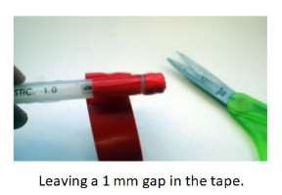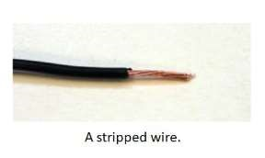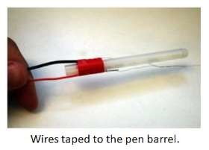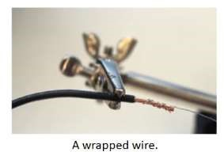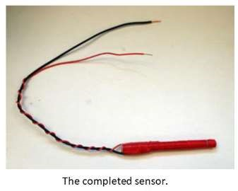

Testing the Probe

Obtain the following materials:

⮚ 4 plastic cups

⮚ table salt

⮚ sugar

⮚ distilled water

⮚ tap water

⮚ prototyping breadboard

⮚ jumper wire(s)

⮚ 470 Ω resistor (yellow-purple-black)

⮚ LED

⮚ 9V battery with wire connectors

Steps:

1. Using a breadboard and the electrical components in the diagram, create the circuit in Figure below. Note the connecting points where the conductivity probe will be connected into the circuit.

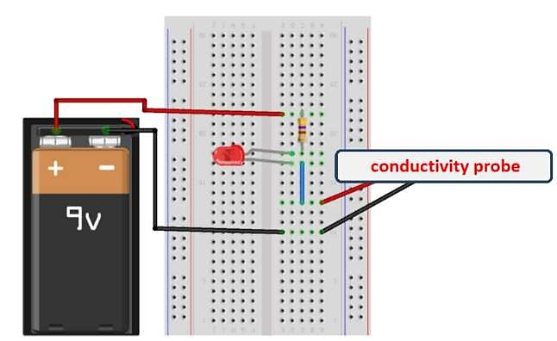

1. Fill three cups approximately halfway with distilled water.
2. Label the three cups as sugar water, salt water and distilled water.
3. Using a spatula or spoon, add a spoonful of sugar into the sugar water cup. Stir the solution until all the sugar has dissolved.
4. Add a spoonful of table salt into the salt water cup. Stir the solution until all the salt has dissolved.
5. Fill a fourth cup halfway with tap water and label it “tap water.”
6. Test your conductivity probe by immersing the tip of the probe into the sugar water solution. Record your observations in Data Table 1.
7. Rinse the probe with distilled water and dry to avoid any contamination among the solutions.
8. Repeat steps 7 and 8 with the salt water, tap water and distilled water.

|  |  |  |  |
| --- | --- | --- | --- |
| Solution |  | LED Glow? | Observations |
| Sugar water | Yes |  | same voltage |
| Salt water | Yes |  | same voltage |
| Tap water | Yes |  | same voltage |

Result: -

Output: -

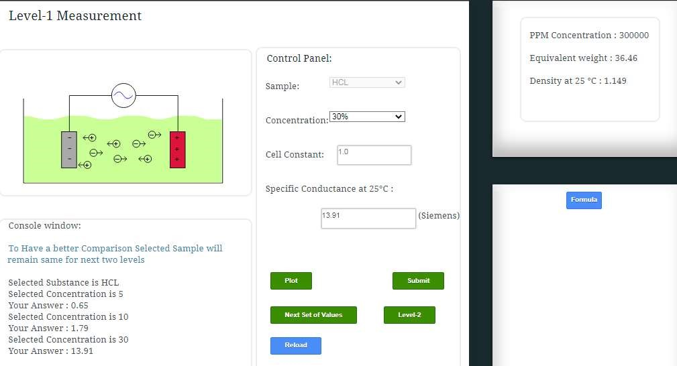

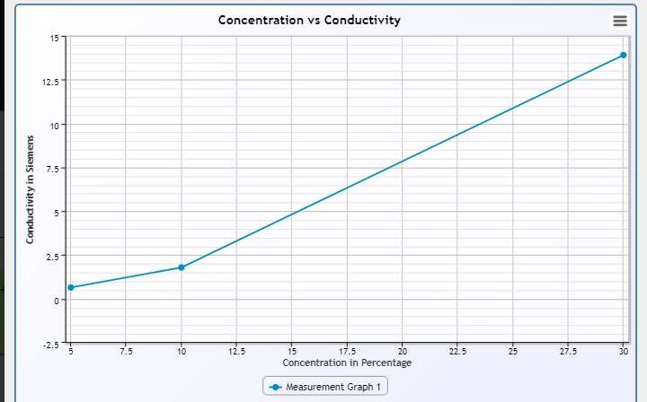

## Level 2

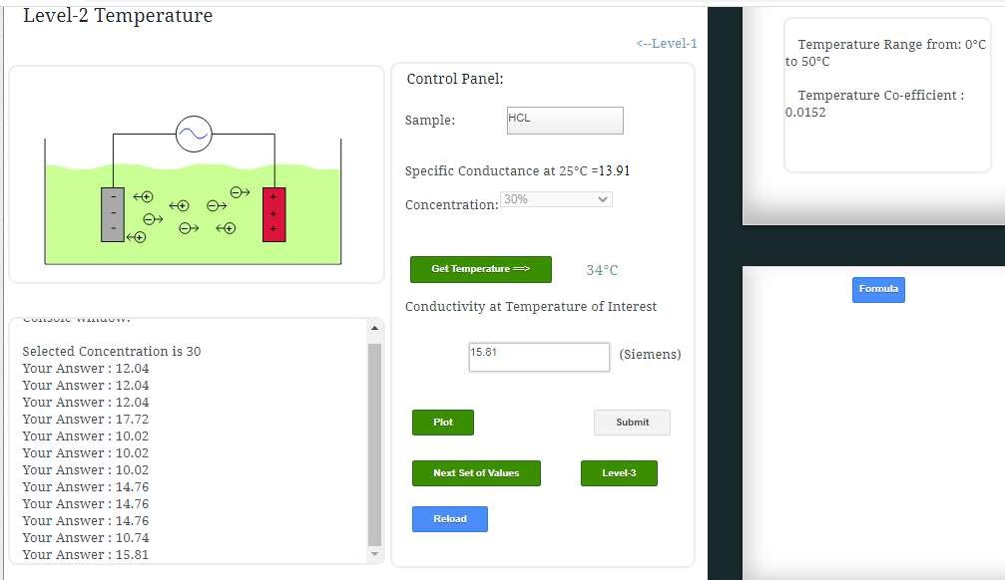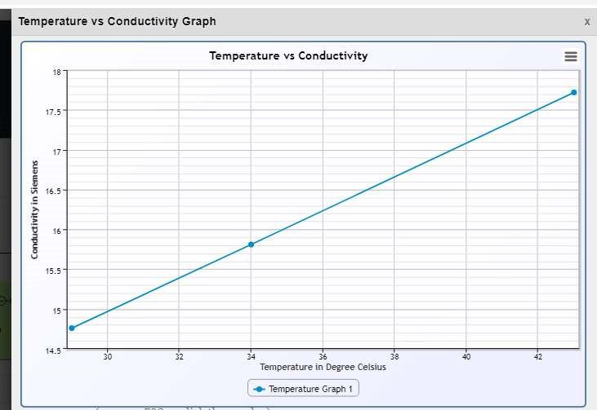

# Level 3

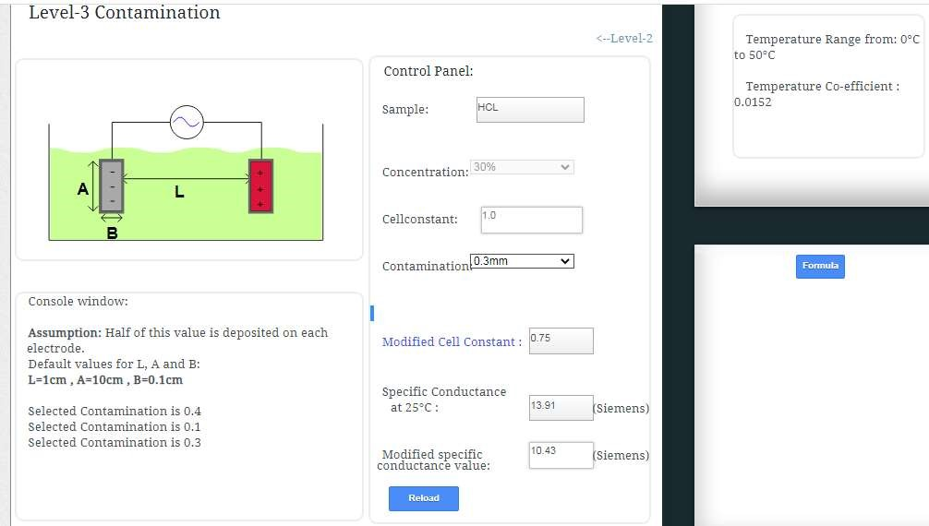

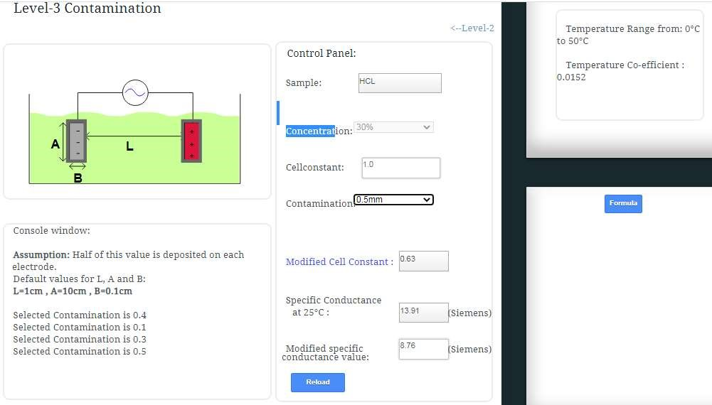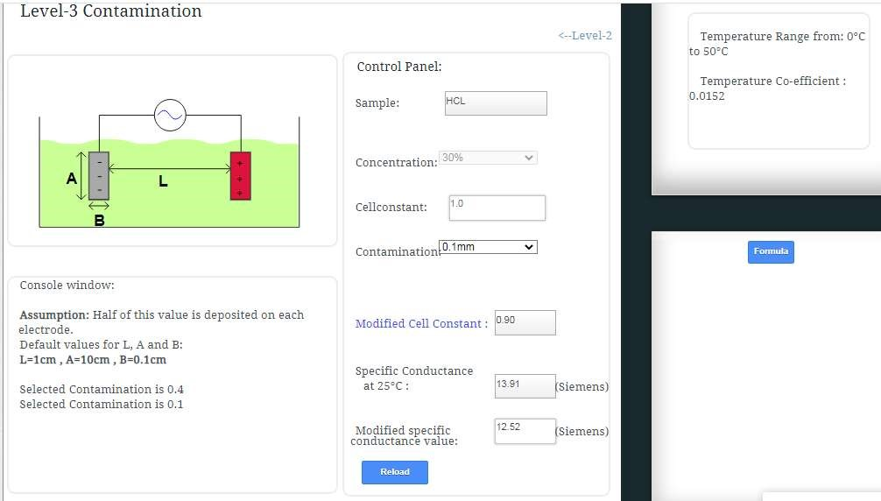

Conclusion-

* The experiment accurately identifies the conductivity of solutions, distinguishing between conductive and non-conductive substances based on measured electrical conductivity readings
* The successful construction of a functional conductivity probe and its seamless integration into a simple circuit demonstrates its reliability in detecting solution conductivity, showcasing its potential for practical use in various applications.

 Shri Ramdeobaba College of Engineering & Management, Nagpur 13

Department of Electronics Engineering

Instrumentation and control lab (ENP354)

Semester: V Session: 2023-24 Section: A Batch: A2

## ****************************************************************************************

Name of Student: Harsh Devendra Mishra Roll Number: 22

Date of performance of Experiment: 23 /11 /2023 Date of Submission of Experiment :30/ 11 /2023

******************************************************************************************

# EXPERIMENT NO. 6

Aim of Experiment: - To understand the working principle of chemical sensors

Objective of Experiment: -

1. Study the working principle of pH and conductivity sensors
2. Calibrate the pH sensor
3. Study the effect of temperature on pH measurement
4. Study effect of temperature and effect of contamination on conductivity measurement

Tool used: - Arduino, Bread Board, Sensor, power supply, Connecting wires, Laptop/Computer system

******************************************************************************************************** pH is a unit of measurement of alkalinity or acidity of a solution, more specifically the pH measures the amount of hydrogen ions that a certain solution contains, the meaning of pH in its acronym is potential of hydrogen ions, this has become a practical way of handling alkalinity figures, instead of other slightly more complicated methods. It can be measured precisely through the use of a tool known as a pH meter, this device can measure the potential difference between a pair of electrolytes.

The hydrogen ion potential scale is numbered from 1 to 14, between 1 and 6 means that the substance is more acidic, 7 is the case of distilled water and has a neutral value, and 8 to 14 means that the substance is more alkaline.

The sequence that the pH scale has is logarithmic, which means that the difference between one numerical unit and another can be 10 times more basic or acidic depending on the case.

What is pH meter, how it works and its technical Specifications

pH meter is an instrument which is used to measure the potential of hydrogen ions in a liquid, and differentiating the acidity and alkalinity of a liquid with numbered units from 0-14. pH meter measures the electrical potential difference between the reference electrode and internal electrode. So it is also called as “potentiometric pH meter”.

The potential difference between electrodes define the acidity of the solution in which the pH sensor is placed.

Working of pH meter

pH meter has a module and a pH electrode where the module has a voltage regulator which can support from 3.3v to 5.5v DC power supply and some has a 5v DC which is compatible with many programable boards like Arduino, ESP 8266, STM and ESP 32. Module equipped with hardware which can output filtered signal with less jitter. The module also has a potentiometer to calibrate the pH electrode.

* The pH measurement loop can be considered as a battery where the positive terminal is the measuring electrode and the negative terminal is the reference electrode.
* The measuring electrode', which is sensitive to the hydrogen ions, develop a potential (voltage) directly related to the hydrogen ion concentration of the solution.
* The reference electrode is stable regardless of any change in the hydrogen ion concentration.
* The pH meter consists of three major components:
* pH probe
* Temperature probe and - The meter
* The pH probe consists of a glass, hydrogen-ion selective electrode, and a reference electrode, combined into a single unit. The glass electrode is specially treated for measuring the hydrogen ions, while the reference electrode is surrounded by silver chloride. It provides a “zero” or reference point for the measurement. This “zero” point means any change in potential measured at the glass electrode is attributed to hydrogen ions, and is expressed as pH. When the temperature and pH probes are immersed in the sample, the meter measures the potential difference between the glass electrode and the reference electrode. This electronic measurement is converted from mill volts to pH units, and the result appears on the display.
* If the temperature probe is not used during the pH measurement, the meter will assume a temperature of 25°C.

Calibration of pH probe with buffer solution

* The calibration must be performed for buffers with pH 4.0, 7.00 and 9.2.
* At least a 2-point calibration must be performed at room temperature using buffers that meet the expected pH value of the sample.
* If a one-point calibration is performed, measurement errors are more for the sample that is being measured.
* If the temperature probe is not used at the time of calibration, default value considered is 25°C.

Installation related issues

* The sensor should be mounted vertically (electrode facing downwards) whenever possible.
* When the probe is mounted at an angle, it should be more than 10º above the horizontal axis.
* Do not mount the sensor completely on its side or upside down.
* Sensor has to be calibrated before it is installed for the process.

1. Electrode and temperature probe rinsing

Soaking the electrode in a pH 4 solution for 10 minutes is essential at the time of installation.

1. Installing/replacing the salt bridge

Hold the sensor with the process electrode pointing upwards. Rinse the reference chamber of the sensor with deionized water. Fill the reference chamber of the sensor with 6 to 7 mL of Reference Cell Buffer solution to ensure the highest possible stability of the reference portion of the pH measurement.

1. Cleaning the sensor

Optimum measurement accuracy depends on both the salt bridge and the measuring electrode glass. Frequency of cleaning depends upon the process solution. Measuring end of the sensor should be carefully wiped with a clean soft cloth. Then rinse it with distilled or de-ionized water. This will help in removing accumulated contamination. Soak the sensor for several minutes in the soap solution to ensure a thorough cleaning. Place the sensor in pH 7 buffer, for about 10 minutes to neutralize any remaining acid.

|  |  |  |
| --- | --- | --- |
| SN | PH (as per Meter) | Temperature (C) |
| Soap Water | 5.46 | 25 |
| Salt Water | 5.91 | 26 |
| Tap water | 6.87 | 26 |
| Distilled Water | 6.65 | 26 |

Result: -

Output: Virtual Labs level 1- PH

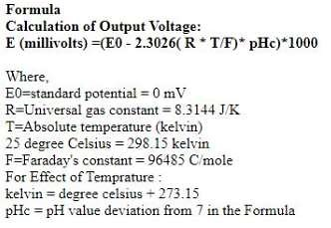

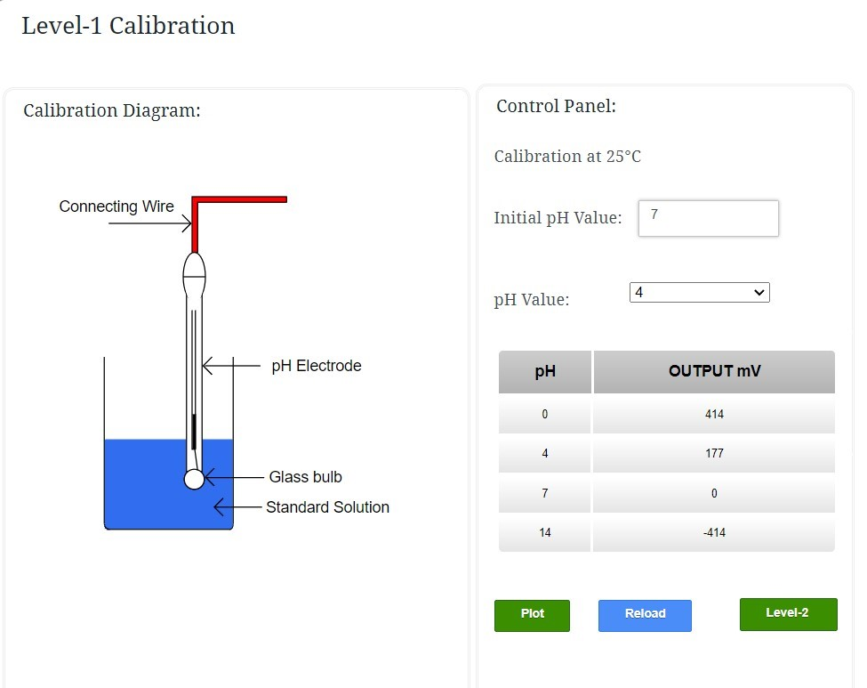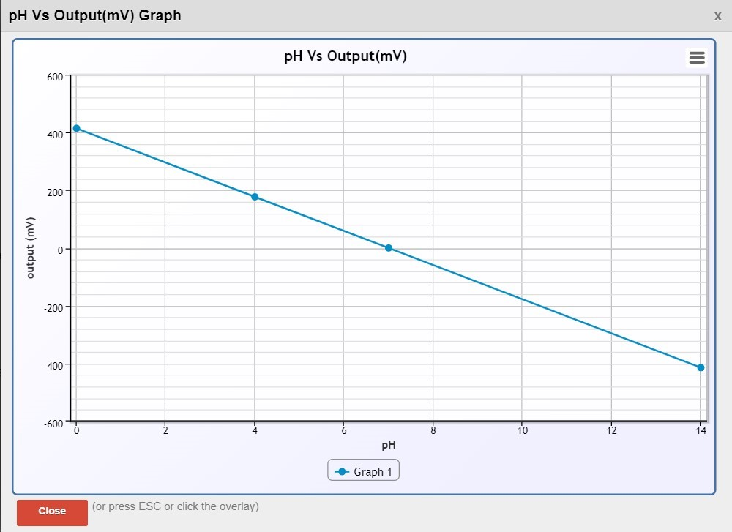

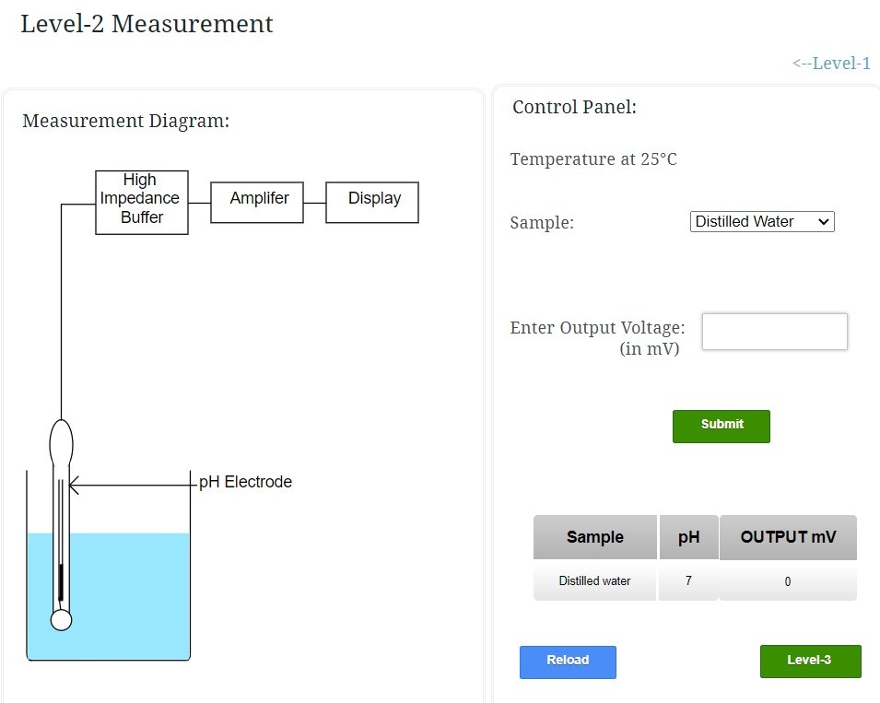

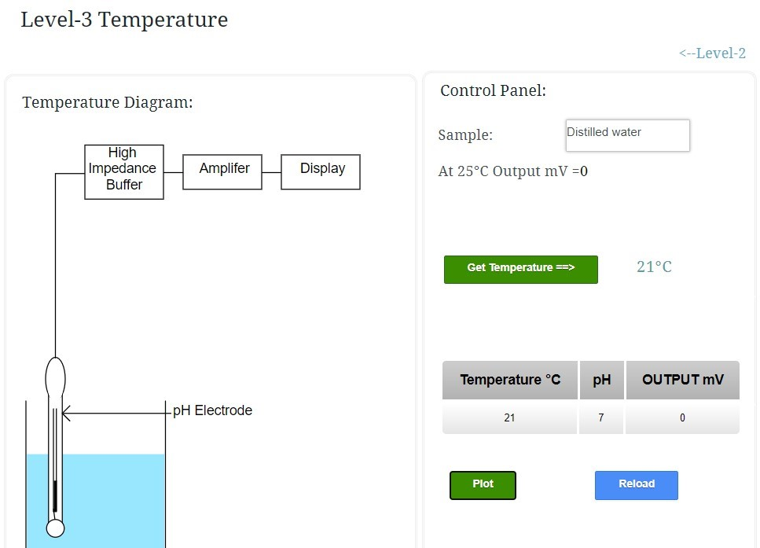

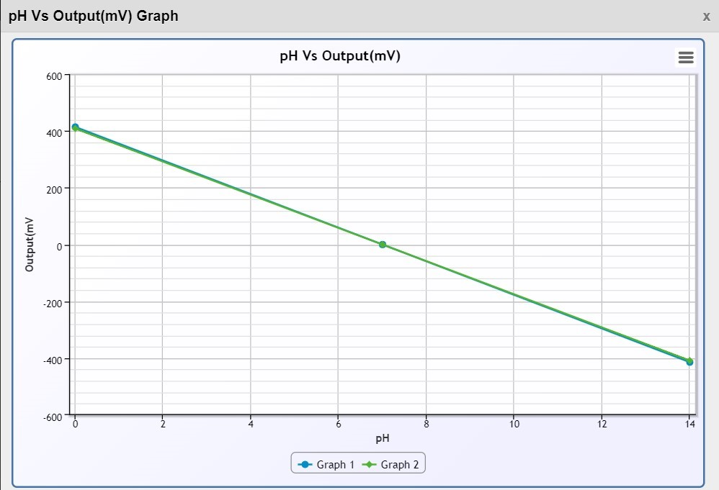

# Sample 2 -

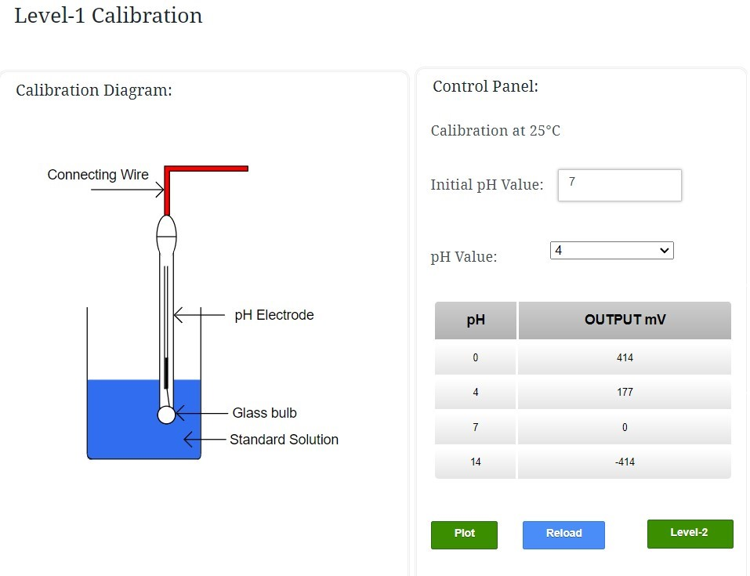

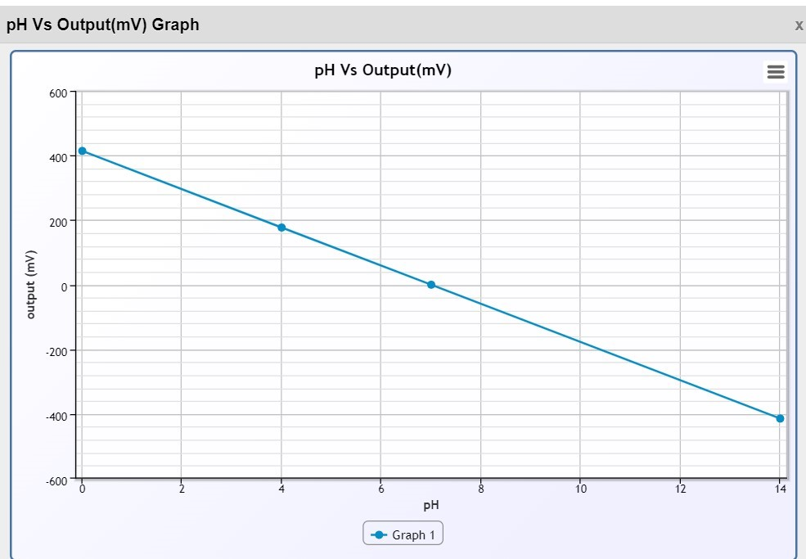

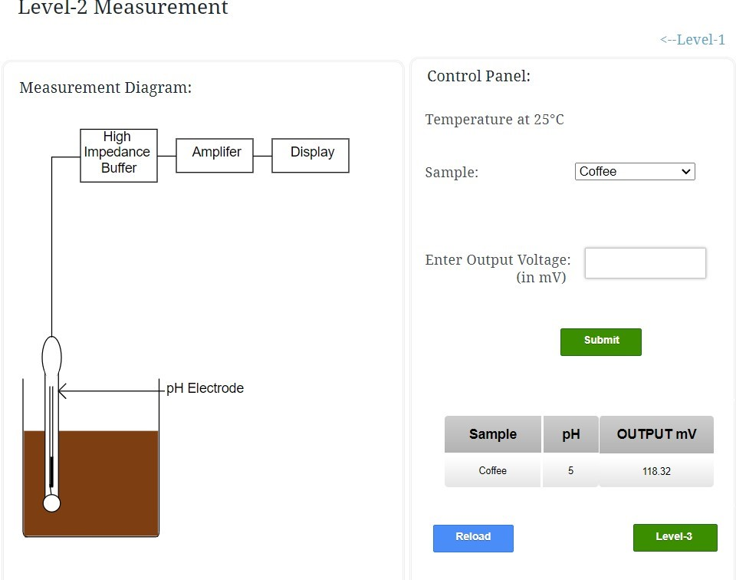

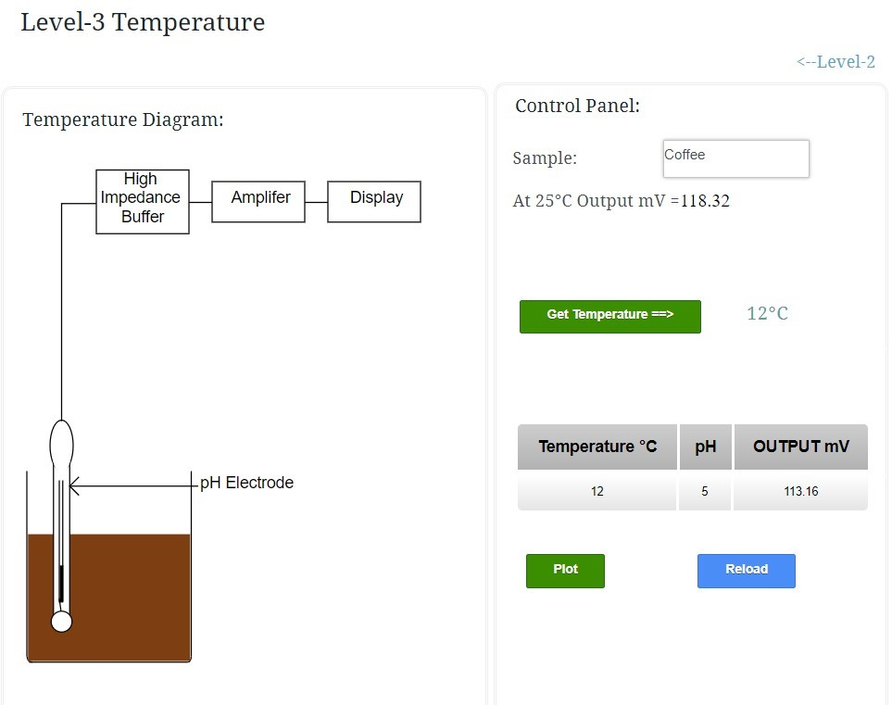

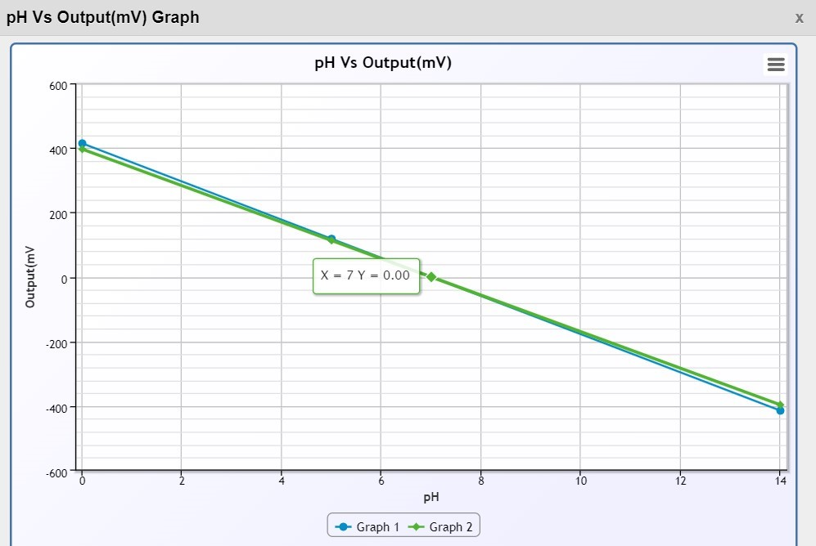

Conclusion:

* In conclusion, delving into the intricacies of chemical sensors has provided a comprehensive understanding of their working principles.
* Both pH and conductivity sensors require proper calibration to ensure accurate readings. Temperature compensation is crucial for minimizing errors caused by temperature fluctuations in both types of sensors.
* Temperature affects pH sensor sensitivity, while both temperature and contamination can influence conductivity sensor readings. Compensation and cleanliness are crucial to minimize these effects.